My Dream Computer System

Introduction
This document outlines my dream computer system, designed for optimal performance, versatility, and future-proofing. It's a high-end build, focusing on top-tier components for demanding tasks like gaming, content creation, and software development.

Central Processing Unit (CPU)
The heart of my dream system is a powerful CPU that can handle any task with ease.

Specifications
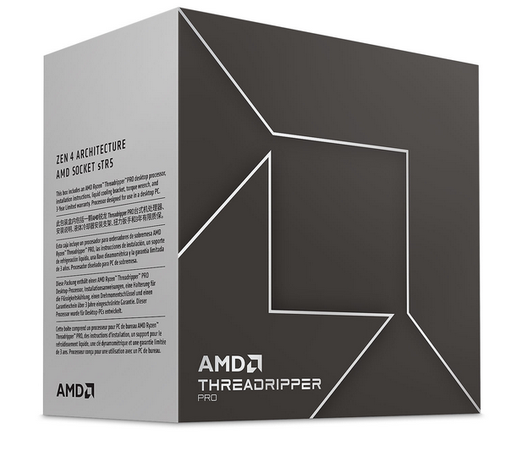
- Model: AMD Ryzen Threadripper PRO 7995WX
- Cores: 96
- Threads: 192
- Base Clock: 2.5 GHz
- Max Boost Clock: Up to 5.1 GHz
- Cache: 384MB
- Socket: sTR5
- Features: Overclockable, PCIe 5.0 support
- Source: Link
Why I chose it: This CPU offers an unparalleled number of cores and threads, making it ideal for heavily multithreaded workloads.

Graphics Processing Unit (GPU)
For graphics-intensive tasks, a high-performance GPU is essential.

Specifications
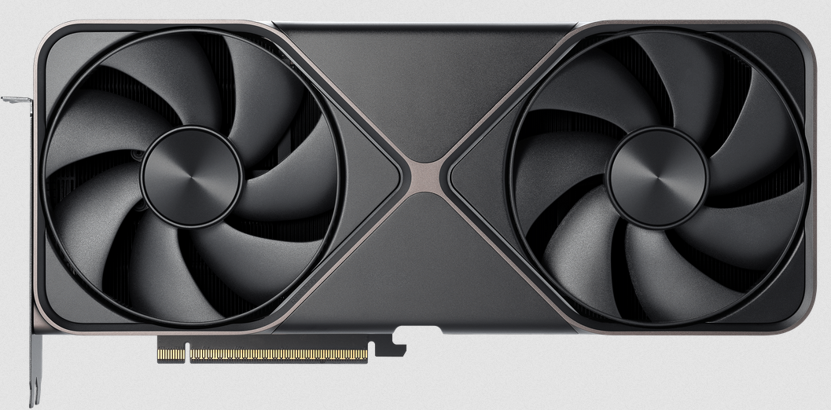
- Model: NVIDIA GeForce RTX 5090
- Memory: 24 GB GDDR7
- Architecture: Ada Lovelace
- CUDA Cores: 16,384
- Boost Clock: 2.52 GHz
- Interface: PCIe 5.0
- Features: Ray Tracing, DLSS 3
- Source: (Hypothetical, as the 5090 is not yet released. Placeholders are common in "dream" system descriptions. When it is released, the actual specs will be available on the NVIDIA website.)
Why I chose it: The RTX 5090 (when released) is expected to provide a significant performance leap over previous generations, delivering stunning visuals and smooth gameplay.

Memory
Fast and abundant memory is crucial for system responsiveness and multitasking.

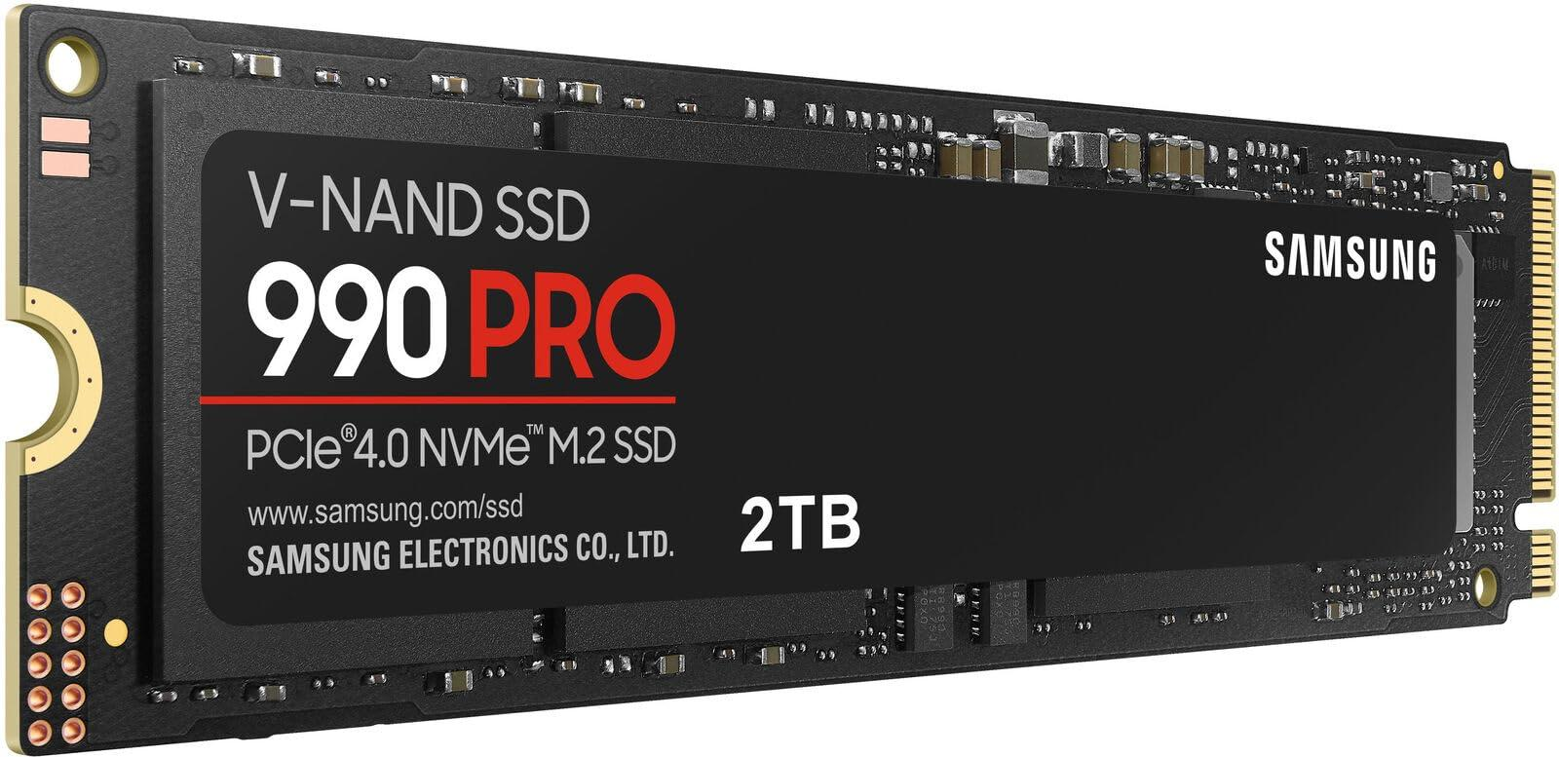
Specifications
- Type: DDR5 ECC
- Capacity: 128 GB (4 x 32 GB)
- Speed: 6400 MHz
- Latency: CL32
- Features: Error Correction Code (ECC), XMP support
- Source: https://www.kingston.com/en/memory/ddr5
Why I chose it: 128GB of high-speed DDR5 ECC RAM ensures smooth performance even with the most demanding applications and provides data integrity.

Storage
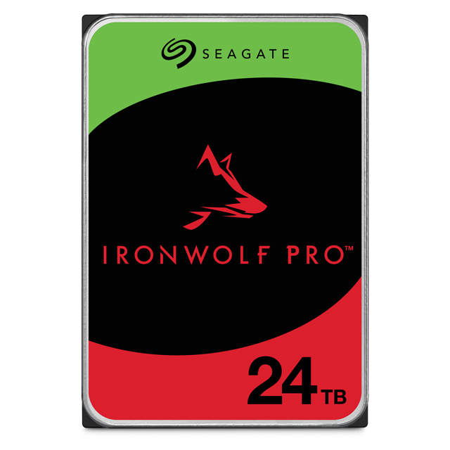
A combination of NVMe SSDs and a high-capacity HDD provides the best balance of speed and storage space.

Specifications
- Primary Storage: 2 x 4TB NVMe PCIe 5.0 SSD
  - Type: Samsung 990 Pro
  - Read Speed: Up to 14,000 MB/s
  - Write Speed: Up to 12,000 MB/s
- Secondary Storage: 10TB HDD
  - Type: Seagate IronWolf Pro
  - Speed: 7200 RPM
  - Interface: SATA III
- Source:
https://www.seagate.com/products/nas-drives/ironwolf-pro-hdd/
Why I chose it: The NVMe SSDs provide lightning-fast boot times and application loading, while the HDD offers ample space for large files and backups.

